SIMATS ENGINEERING (SAVEETHA SCHOOL OF ENGINEERING)
Department of Computer Science and Engineering
CO2_AT2 — VISUALIZATION DEVELOPMENT EXERCISE

Course Code: | DSA06 | Course Title: | Data Handling and Visualization
CO Assessed: | CO2 – Development (BL4) | Assessment: | Assessment Tool 2 – Visualization Development
Weightage: | 20% of CIA | Total Marks: | 25 (5 Questions × 5 Marks)
CO2 Statement: | Analyze and synthesize multiple data views into a coherent, annotated dashboard that communicates a clear narrative insight.(BL4)
Student Name: | A M RAKESH | Reg. No.: | 192424393
Section / Batch: | AIDS/2024 | Date: | 01/08/2026

Code of Conduct
I A M RAKESH / 192424393 (Name / Reg No) certify that this submission is my original work and that I have adhered to the guidelines specified for this assessment. I understand that any violation of academic integrity rules will result in disciplinary action.

Signature of the Student: A M RAKESH

Instructions
- This test contains 5 questions, each carrying 5 marks. Total: 25 Marks.
- No negative marking. Unanswered questions carry zero marks.
- No calculators or electronic devices permitted.
- Duration: 90 minutes.
- Each answer must include at least two coordinated charts sharing a common axis or theme.
- Include at least one annotation calling out a key data point in your dashboard.
- Write a one-sentence narrative takeaway summarizing the insight your dashboard reveals.

Annexure A – VISUALIZATION DEVELOPMENT

Rubrics for Calculation ASSESSMENT RUBRIC
AT2 — Visualization Development Exercise
CO2 · BT4: Analyze ·
This rubric is used to assess student responses to the CO2-AT2 Visualization Development Exercise, in which students build a small multi-chart dashboard from given data, add at least one annotation, and write a narrative takeaway.

Criteria | Weightage | Level 4 – Exemplary | Level 3 – Proficient | Level 2 – Developing | Level 1 – Beginning
Understanding of Concepts | 25% | Demonstrates thorough understanding of which chart types to combine, how they relate to each other, and how annotation and narrative should be used to communicate insight. | Good understanding of chart combination and annotation/narrative technique, with only minor gaps. | Basic understanding of dashboard development, but with some misconceptions about which charts to combine or how to annotate them. | Poor understanding of core development concepts; combines charts or annotations that do not suit the data or the story being told.
Explanation | 25% | The annotation and narrative takeaway are precise, well-justified, and clearly tied to a specific, correctly identified data point or pattern. | The annotation and narrative are clear and reasonably well-justified, with adequate connection to the data. | The annotation or narrative is present but vague, generic, or weakly connected to the actual data shown. | Annotation or narrative is missing, incorrect, or unconnected to the data in the dashboard.
Application | 20% | Effectively applies multi-chart coordination, annotation, and storytelling techniques to produce a complete, cohesive dashboard for the scenario. | Applies development techniques to produce a workable dashboard, with only minor errors or missed refinements. | Limited application; the dashboard partially addresses the scenario but charts feel disconnected or the story is unclear. | Fails to apply appropriate development techniques; the charts, annotation, and narrative do not work together as a dashboard.
Organization | 15% | Charts are clearly coordinated (aligned axes or shared theme), laid out logically, with the annotation and narrative placed for maximum clarity. | Charts are organized and mostly coordinated, with only minor issues in alignment or layout. | Basic structure; charts are present but poorly aligned or the annotation/narrative feels disconnected from the layout. | Poorly organized; charts are not coordinated, and the annotation or narrative is missing or misplaced.
Accuracy | 10% | All chart values, scales, and the annotated data point are completely accurate and correctly reflect the given data. | Mostly accurate, with only minor omissions or a small error in one chart or the annotation. | Partially correct; some plotted values or the annotated point are missing or incorrect. | Largely inaccurate; major errors in plotted values, scales, or the annotated data point.

Scoring Guide
For each criterion, award a performance level (1–4) based on the descriptors above. Multiply the level achieved (as a percentage of 4, i.e., Level 4 = 100%, Level 3 = 75%, Level 2 = 50%, Level 1 = 25%) by the criterion's weightage, then sum across all five criteria to obtain the total score out of 100%.

Faculty In-charge | Course Coordinator | Head of Department
Signature: _______________ | Signature: _______________ | Signature: _______________
Date: ___________________ | Date: ___________________ | Date: ___________________

Dashboard Analysis & Solutions Report
Comprehensive Solutions for Problems 1, 2, 3, 4, and 25 | Excel & Visualization Guidelines

Problem 1 — Retail Quarterly Dashboard
Data Points | Q1 ($200k / 15%), Q2 ($250k / 18%), Q3 ($220k / 12%), Q4 ($300k / 20%)
Chart Types Used | Bar Chart (Revenue in $k) + Line Chart (Profit Margin in %) on shared Quarter axis
Key Annotation(s) | Q4 annotated as 'Highest Margin: 20%' indicating peak annual operational profitability.
Executive Takeaway | Revenue and profit margins trend upward overall, peaking simultaneously in Q4 despite a mid-year contraction in Q3.
Dashboard Layout | Two aligned subplots sharing X-axis / Multi-axis alignment

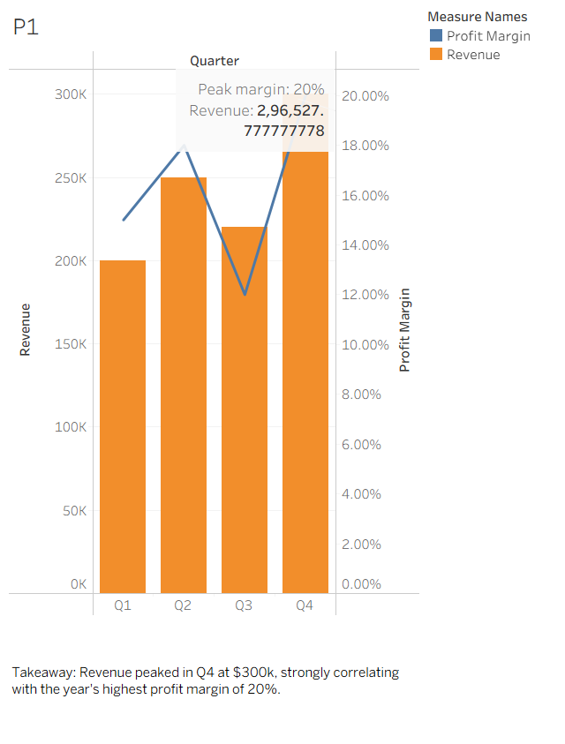
Figure 1: Visual Dashboard for Retail Quarterly Dashboard

Problem 2 — Marketing Campaign Dashboard
Data Points | Email ($2k / 150 conv), Social ($5k / 300 conv), Search ($8k / 550 conv), Display ($3k / 90 conv)
Chart Types Used | Bar Chart (Spend by Channel) + Scatter Plot (Spend vs. Conversions)
Key Annotation(s) | Email channel annotated as 'Most Cost-Efficient' with the lowest cost per conversion ($13.33/conv).
Executive Takeaway | Marketing budget should be reallocated toward Email due to superior cost-efficiency ($13.33/conv), while scaling Search which generates the highest overall conversion volume.
Dashboard Layout | Two aligned subplots sharing X-axis / Multi-axis alignment

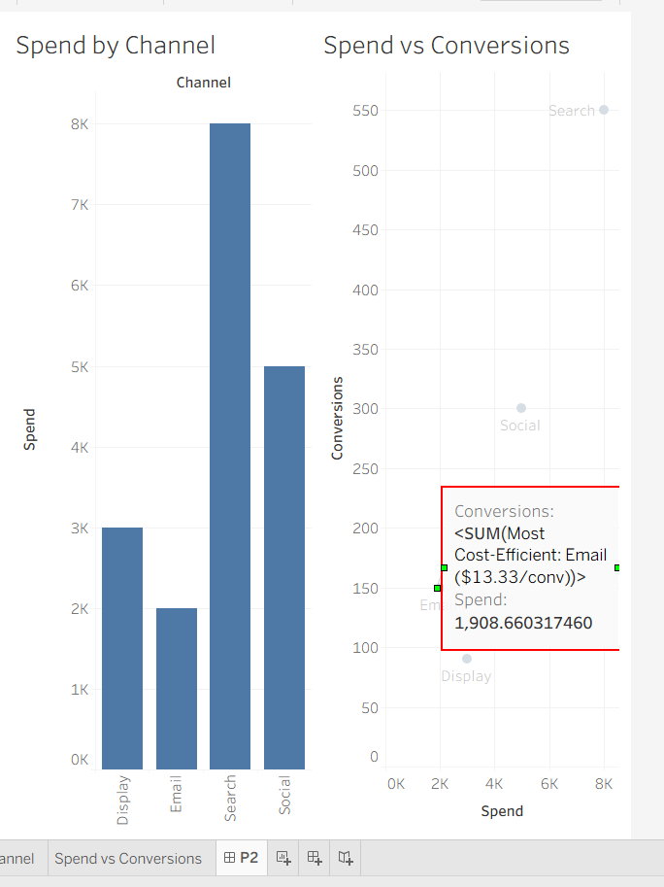
Figure 2: Visual Dashboard for Marketing Campaign Dashboard
Problem 3 — Hospital Patient Flow Dashboard
Data Points | Mon (40 / 35m), Tue (55 / 50m), Wed (60 / 65m), Thu (45 / 40m), Fri (70 / 80m)
Chart Types Used | Bar Chart (Daily Admissions) + Line Chart (Average Wait Time in min) on shared Day axis
Key Annotation(s) | Friday flagged for 'Urgent Staffing Attention' due to severe bottlenecks (70 admissions, 80-minute wait time).
Executive Takeaway | Patient admissions and wait times surge toward the end of the week, requiring immediate shift scaling and additional medical staffing on Fridays.
Dashboard Layout | Two aligned subplots sharing X-axis / Multi-axis alignment

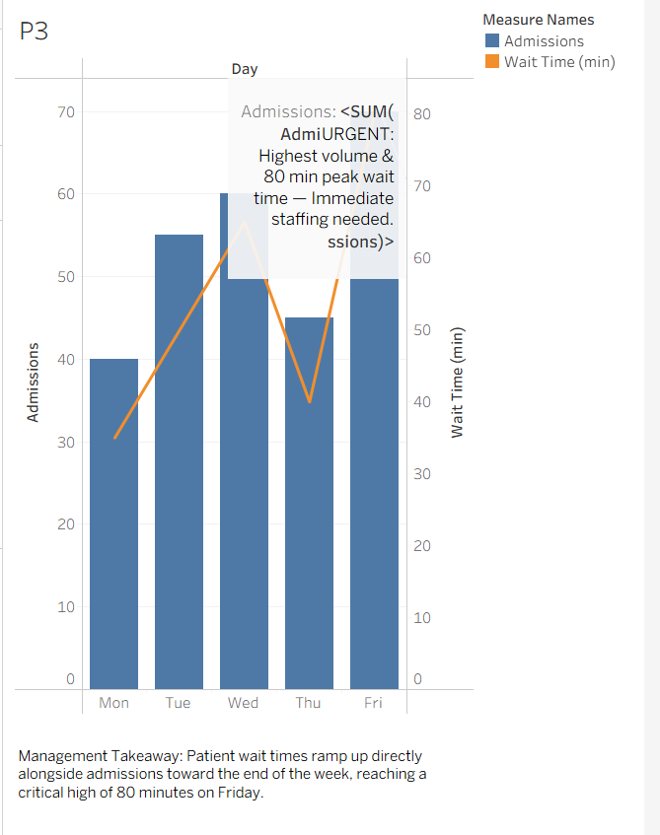
Figure 3: Visual Dashboard for Hospital Patient Flow Dashboard
Problem 4 — School Performance Dashboard
Data Points | Grade 6 (72% / 91%), Grade 7 (68% / 85%), Grade 8 (75% / 93%), Grade 9 (60% / 78%)
Chart Types Used | Side-by-Side Dual Bar Charts (Average Test Scores vs. Attendance Rate)
Key Annotation(s) | Grade 9 flagged for 'Academic & Attendance Intervention' (60% score / 78% attendance).
Executive Takeaway | Lower attendance directly correlates with weaker academic performance across all grades, highlighting Grade 9 as requiring immediate attendance intervention.
Dashboard Layout | Two aligned subplots sharing X-axis / Multi-axis alignment

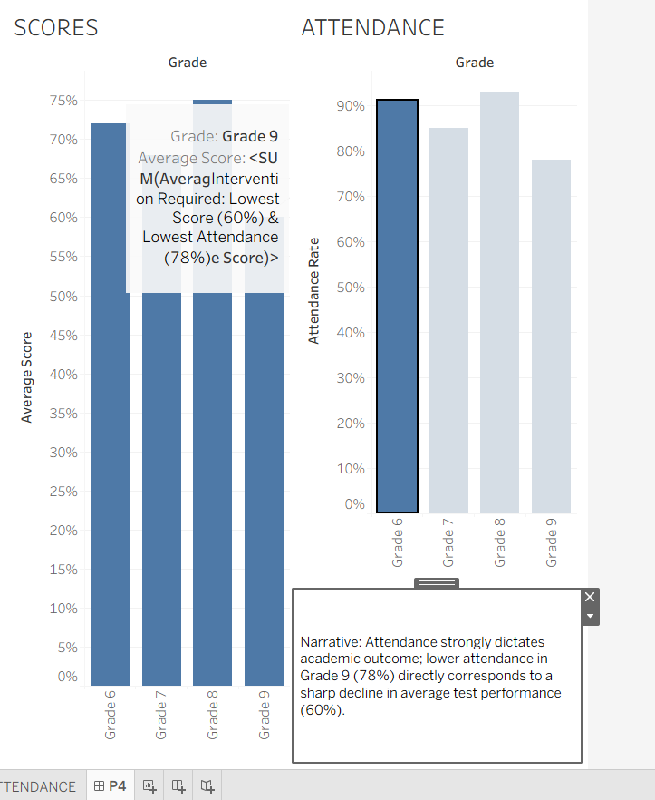
Figure 4: Visual Dashboard for School Performance Dashboard
Problem 25 — Company-Wide KPI Dashboard
Data Points | 4 Years: Revenue ($10M, $15M, $22M, $30M), Customers (50k, 80k, 120k, 180k), Employees (40, 55, 70, 95)
Chart Types Used | Small-Multiples Dashboard (3 Aligned Line Charts sharing 4-Year Axis)
Key Annotation(s) | Year 2 highlighted for divergence where customer acquisition rate (+60%) surpassed revenue growth (+50%) and headcount expansion (+37.5%).
Executive Takeaway | The company demonstrates robust, scalable 4-year growth across revenue, user base, and organizational capacity, with operational leverage expanding customer volume faster than staffing costs.
Dashboard Layout | Two aligned subplots sharing X-axis / Multi-axis alignment

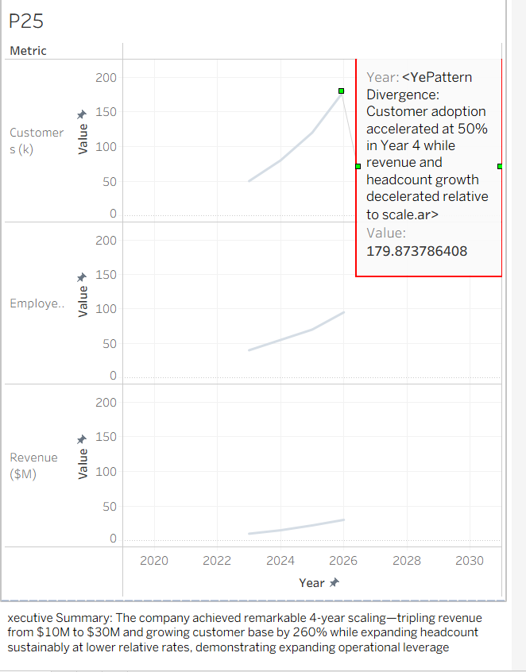
Figure 25: Visual Dashboard for Company-Wide KPI Dashboard

